MIDDLESEX UNIVERSITY STUDENTS’ UNION

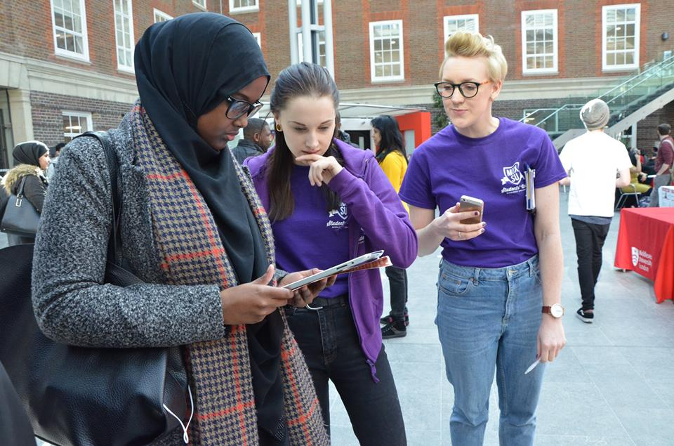
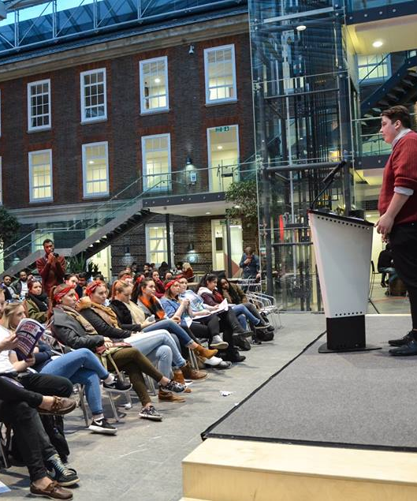

Community Placement Pack
[Name of the opportunity]

www.mdxsu.com

Community Placement Brief
Here at Middlesex University we want students to be at the heart of our local community and for the local community to see the University at its heart.

We are excited to be offering Community Placements across the borough. These are not volunteering opportunities they are paid placements. They give our students the chance to develop their academic studies in a real world setting. They also give our students the chance to give something back to their local community. All MDXSU placements are paid in line with the London Living Wage Foundation.

[Name of the opportunity]
Hours: 4 per week, over 6 weeks
Supervised by:
Location: Based at ….

All MDXSU Community Placements are paid according to the Living Wage Foundation rate for London (£9.75p/h)

[Please include a paragraph about your organisation and the impact you have in the local community]

[Please include a paragraph about the opportunity and how it will make a difference to your organisation]

Join us in making a positive difference in the local community!

Role Description

[Name of the opportunity]
Supervised by: | [As above]
Salary: | London Living Wage (@ £9.75 per hour)
Duration: | 6 weeks
Hours: | 4 hours per week
Location: | [As above]

PLACEMENT PURPOSE

- Please include a couple of bullet points to describe the objectives of this opportunity

- Be an ambassador and representative for the Students’ Union.

Person Specification

CRITERIA | Requirement
QUALIFICATIONS
Current enrolled student and studying at Middlesex University | Essential
ATTRIBUTES/SKILLS
Strong interpersonal and communication skills | Essential
Excellent organisational ability | Essential
Proactive and able to work using own initiative | Essential
Ability to work flexibly | Essential
Excellent written communication and readable style | Desirable
Please include any additional criteria that you would candidates to display
VALUES AND ETHICS
Positive attitude and enthusiasm about Middlesex University and MDXSU | Essential
Positive attitude towards services for young people | Essential
Please include any additional criteria that you would candidates to display
KNOWLEDGE
Studying related programme (eg Public Relations) | Desirable
Please include any additional criteria that you would candidates to display
SPECIAL CONDITIONS
Please include any additional criteria that you would candidates to display

Further Information

Please visit our Community Placement webpages at https://www.mdxsu.com/community-placements to complete an online application form.

Application deadline:
Shortlisting:
Interview date:

We will be completing the shortlisting process as soon as possible following this time. Please note however that due to the number of applications that the students’ union receives for placement opportunities, we are unable to offer personal feedback on applications.

Shortlisted candidates will be invited to interview. The interview will be held on xxxxxxxxxxxxxxxx and will take place XXXXXXXXXXXXX.

If you need any additional information or if you would like to speak to someone about your application please contact communitypartnerships@mdxsu.com or call 020 8411 5785

At MDXSU we want our students to have the opportunity to give back into the local community.
We think these opportunities should build our students employability and fit around their studies. We think they should be open to everyone and be available to those who need paid work to support themselves while at University.
All of our Community Placements are paid in line with the Voluntary London Living Wage.
This Academic Year we hope to offer up to 100 opportunities.
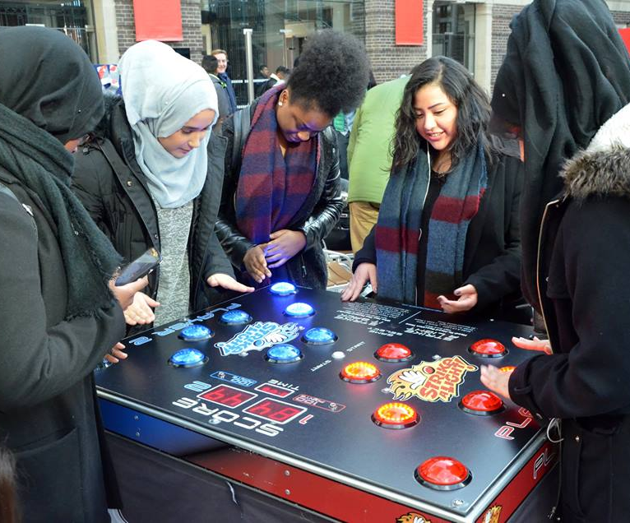
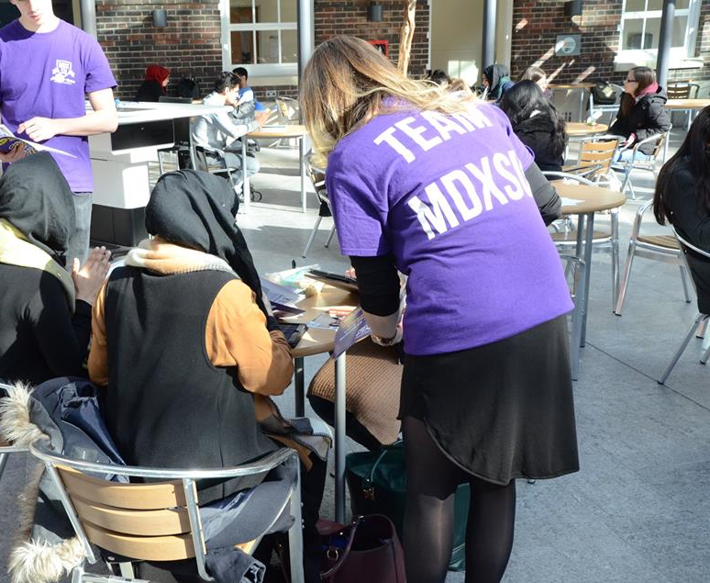

www.mdxsu.com

